Unit 3 Northwind Login Screenshots and Repository Link

Corey Crooks
Purdue University Global
IT481 – Advanced Software Development
Ahmad Kassem
May 10th, 2023

Program at startup:
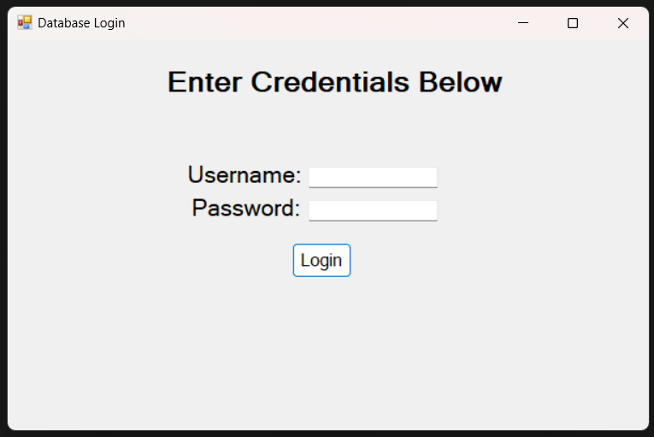

Program entering wrong credentials:
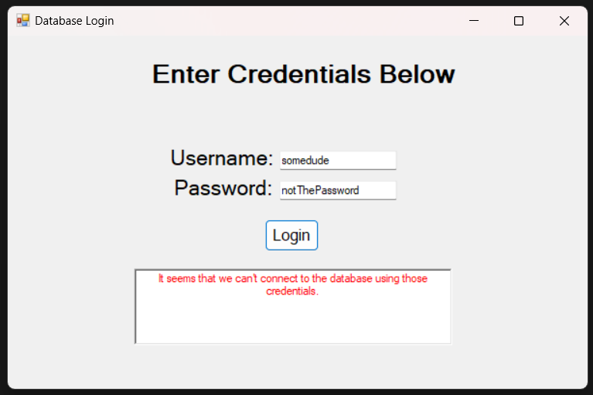

Program logging in as CEO:
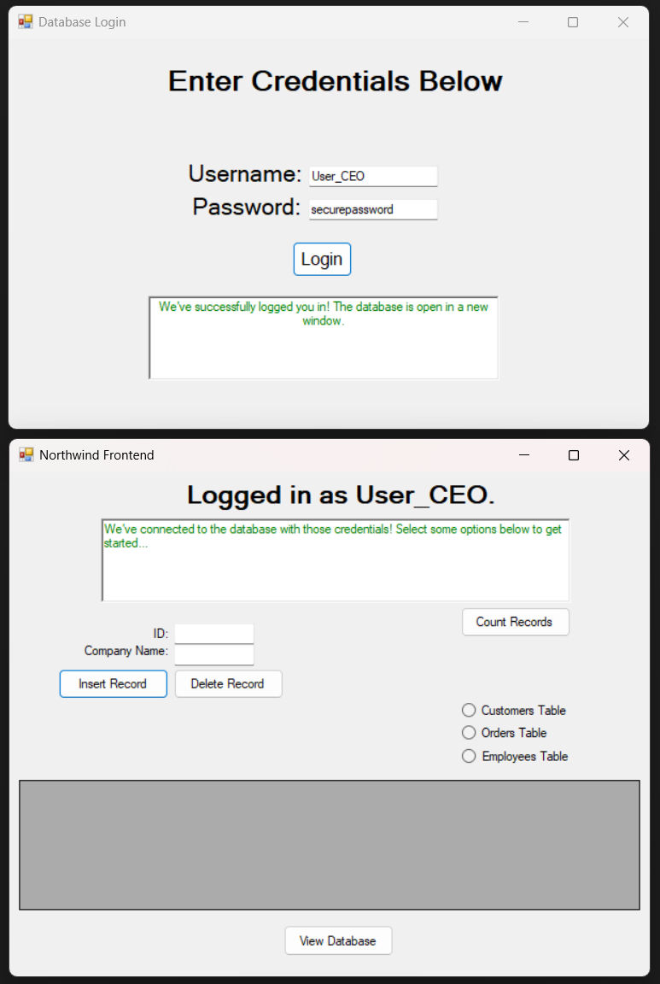
Program with invalid input (no table selection):
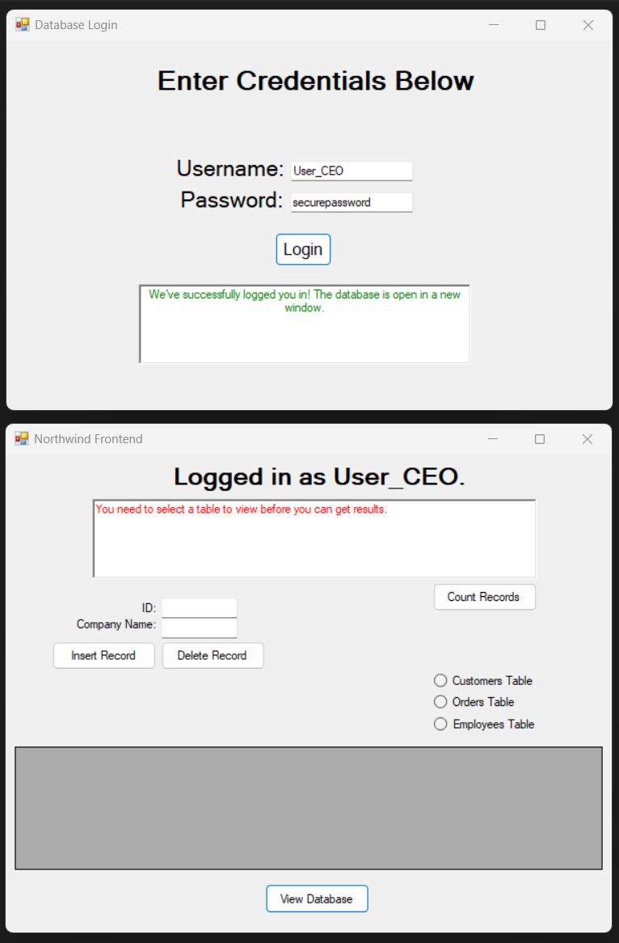
Program logging in as HR:
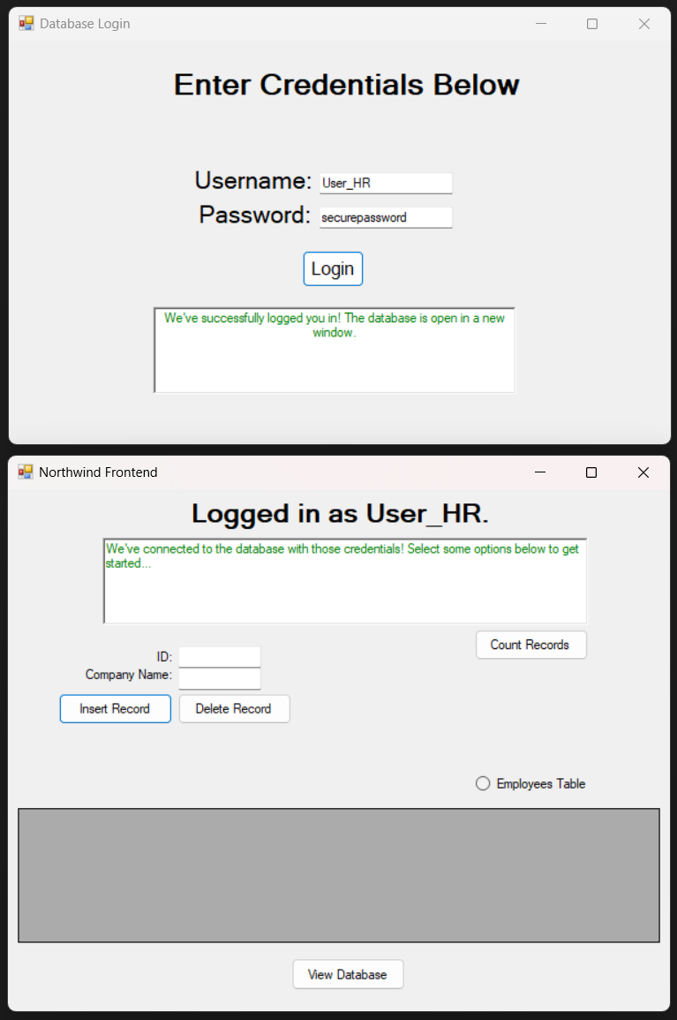
Program viewing records as HR: 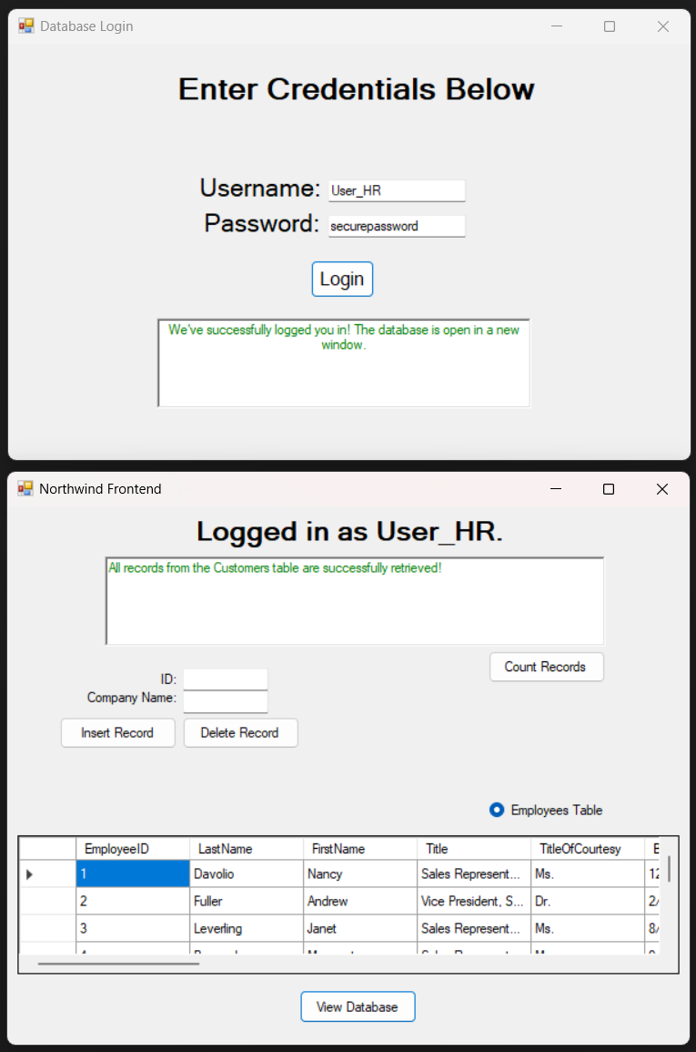
Program logging in as Sales:
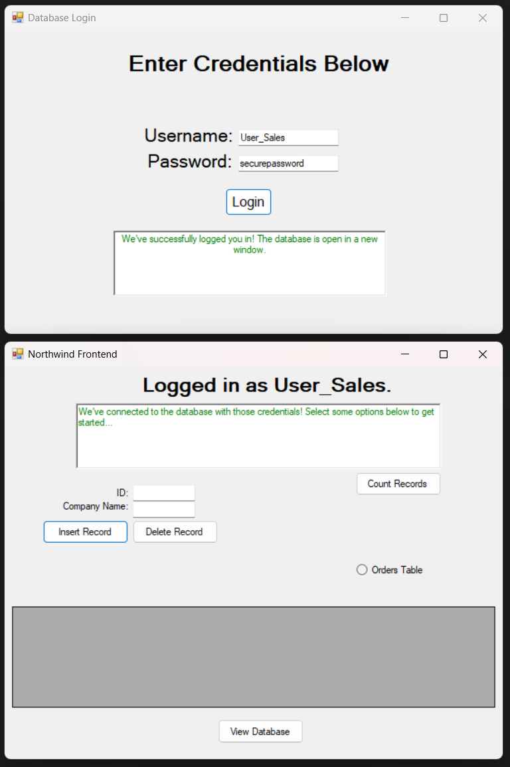
Program viewing records as Sales:
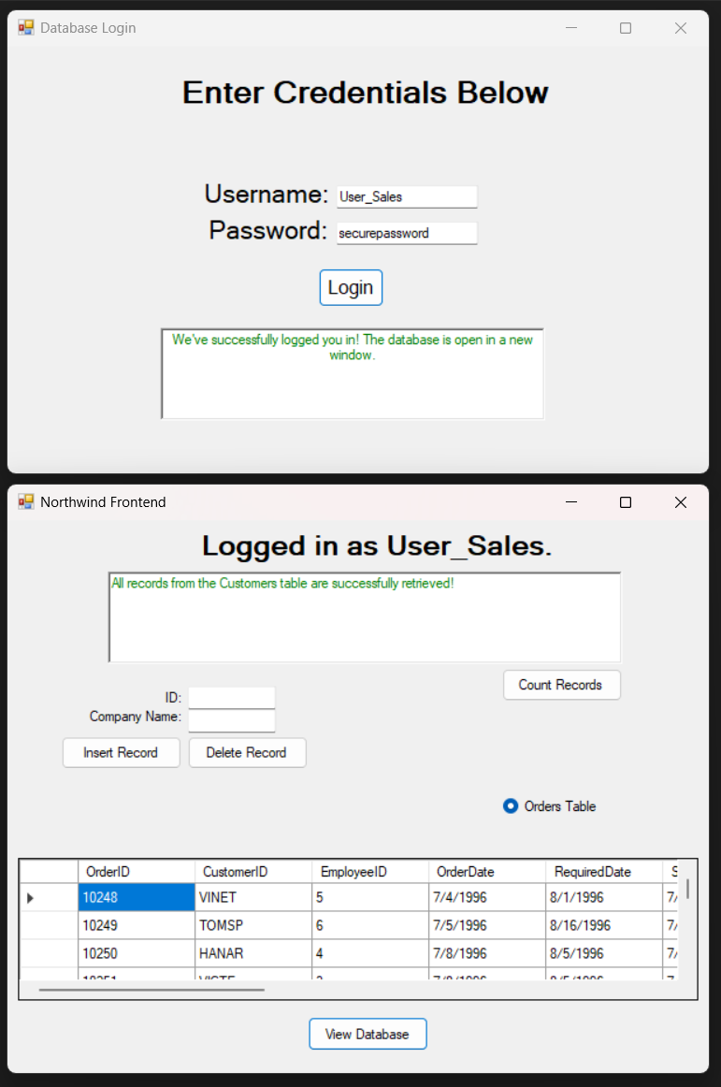
SCM Proof and Link (Including SQL Script):
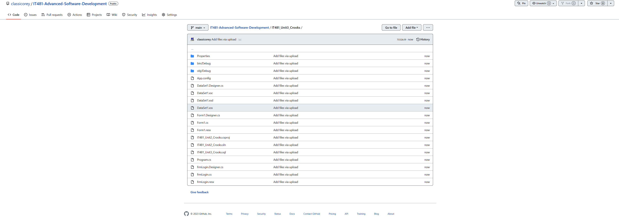
URL:
https://github.com/classicorey/IT481-Advanced-Software-Development/tree/main/IT481_Unit3_Crooks

